Muhammad Sami Rizwan   
Jawan Pakistan   
Section B

**1) Install Flutter, make a project by “Flutter create projectname” and then run app by “flutter run”**

**and take screenshot.**

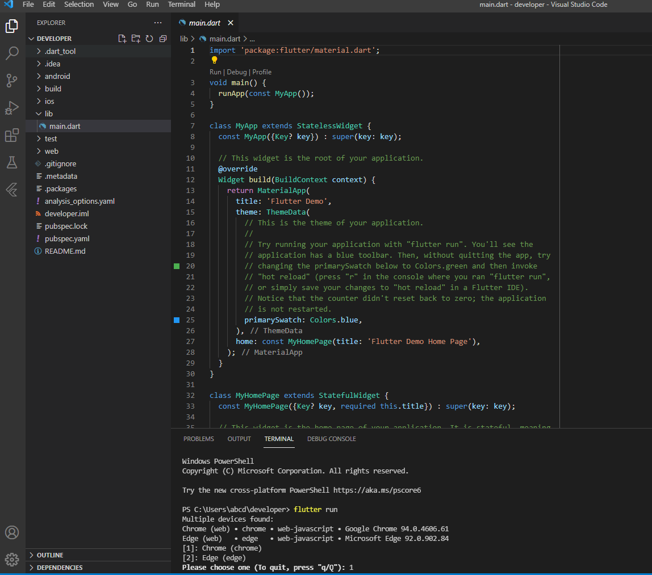

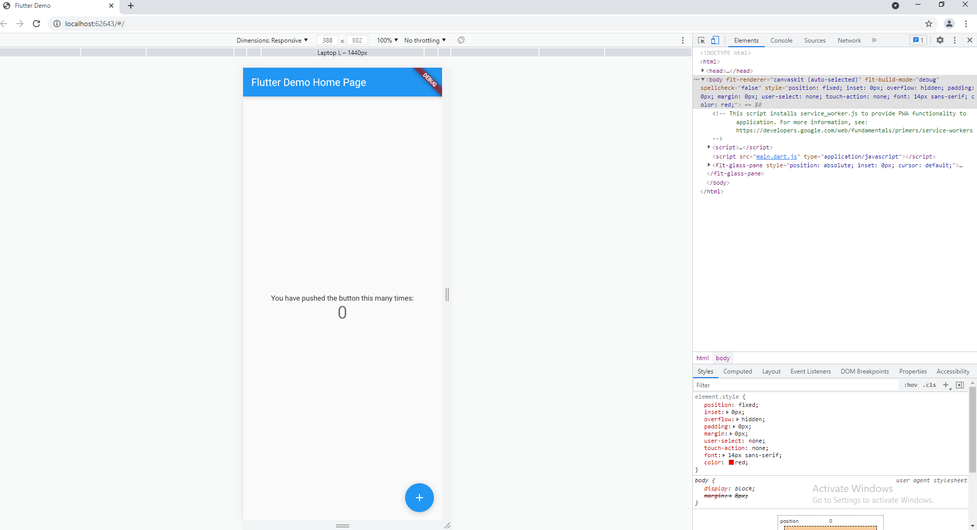

**2) To make a function that take a number as parameter, and print the table of that number.**

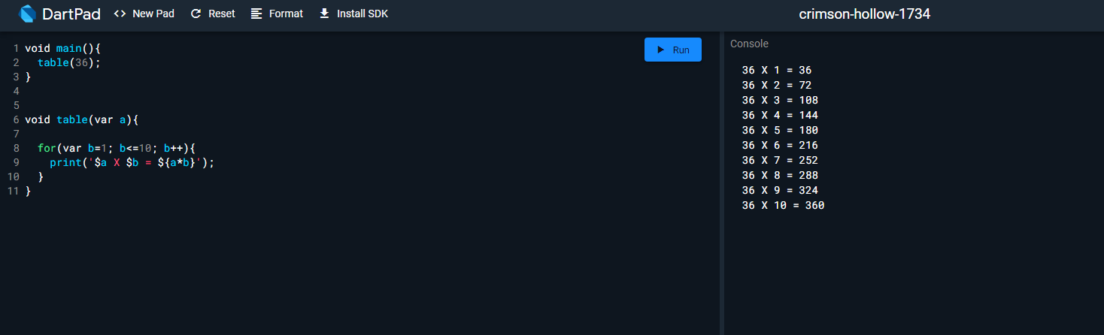

**3) List lst = [2,4,6,8,9];**

**Make a function that takes a number as parameter and divide that parameter to every element**

**in the list**

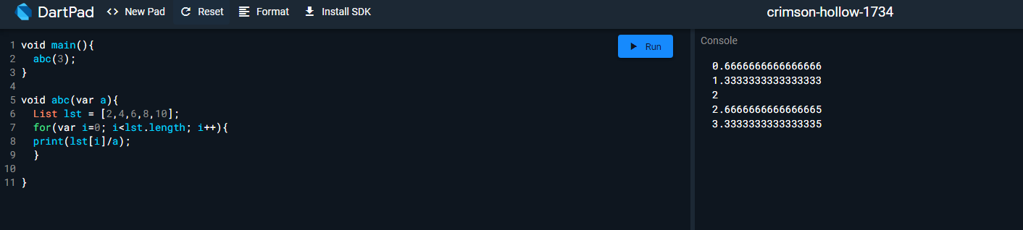

**4) Make a function for printing mark sheet then Make a list of at-least 5 names and another list of**

**their marks, and print the mark sheet of all of them.**

**5) Make a function in class and then call it outside class.**

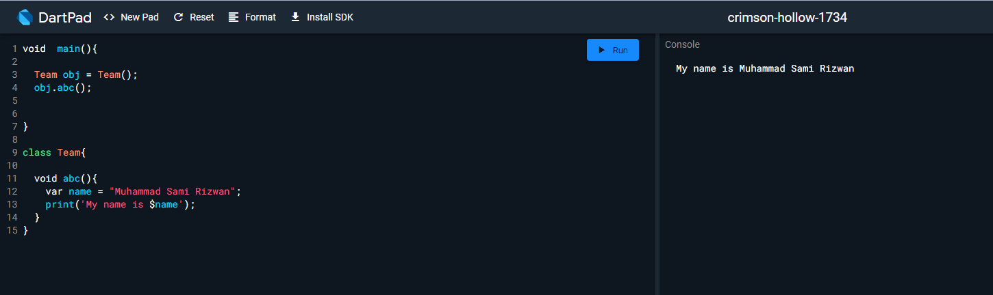

**6) Print your name in a sentence using classes.**

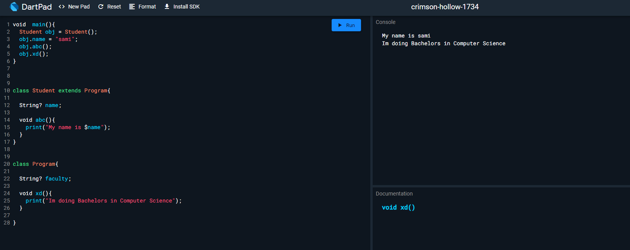

**7) Make a constructor that requires your name, age, education and then print that.**

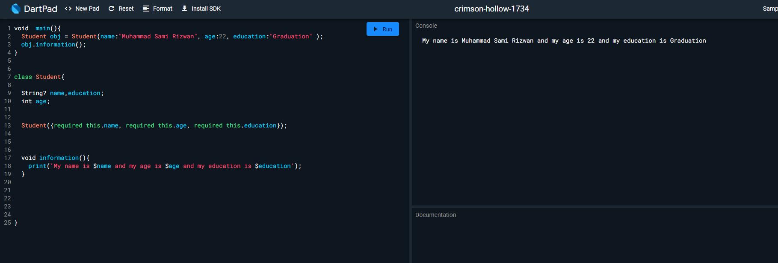

**8) Write a Code using inheritance.**

